WEEK 2: SECURITY IMPLEMENTATION REPORT
DEVELOPERSHUB CORPORATION CYBERSECURITY INTERNSHIP
Intern Name: | Ayesha
GitHub: | github.com/aisha-cybersec/developershub-cybersecurity-internship
Organization: | DevelopersHub Corporation
Internship Domain: | Cybersecurity
Report Week: | Week 2 Security Implementation
Submission Date: | 24 May 2026
Application: | OWASP Juice Shop v14.5.1
Tools Used: | Node.js v18.20.8, npm, VS Code, validator, bcrypt, jsonwebtoken, helmet

1. Introduction
This report documents the tasks completed during Week 2 of the DevelopersHub Corporation Cybersecurity Internship Program. Building upon the vulnerabilities identified in Week 1 SQL Injection, Cross-Site Scripting (XSS), Weak Password Policy, and Security Misconfigurations — the focus of Week 2 was to implement concrete security fixes using industry-standard Node.js security packages.
Four security packages were installed and integrated:
- validator input validation and sanitization
- bcrypt secure password hashing with salt rounds
- jsonwebtoken (JWT) token-based authentication
- helmet HTTP security headers

2. Task 1: Security Package Installation

2.1 Environment Setup
The correct Node.js version was activated using NVM before navigating to the Juice Shop directory:
nvm use 18.20.8
cd Desktop\juice-shop

2.2 Installing Security Packages
All four security packages were installed using a single npm command:
npm install validator bcrypt jsonwebtoken helmet

Figure 1 shows the installation command being initiated:
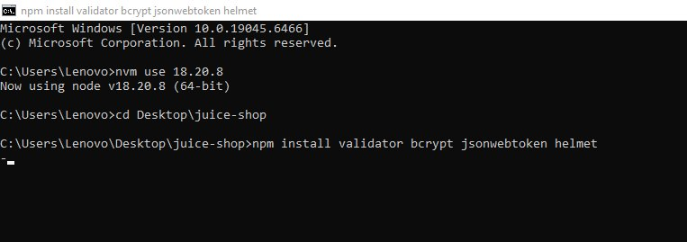
Figure 1: npm install command initiated validator bcrypt jsonwebtoken helmet

Figure 2 shows the completed installation output confirming successful package installation:
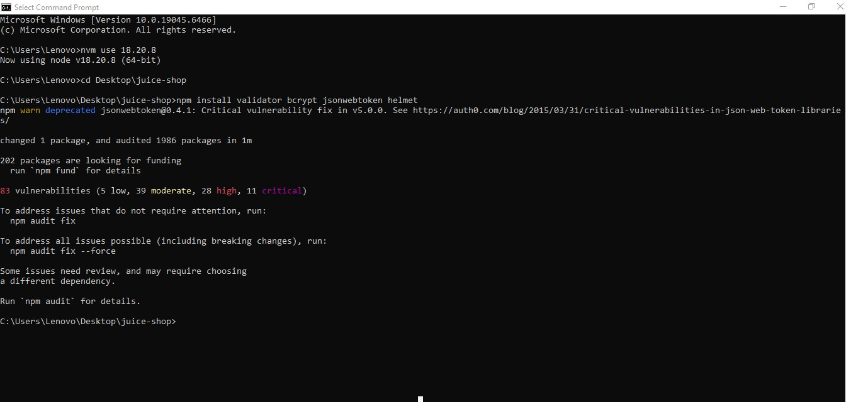
Figure 2: Security packages installed successfully 1 package changed, 1986 packages audited

2.3 Application Verification After Installation
After installing packages, the Juice Shop application was started to confirm no dependency conflicts:
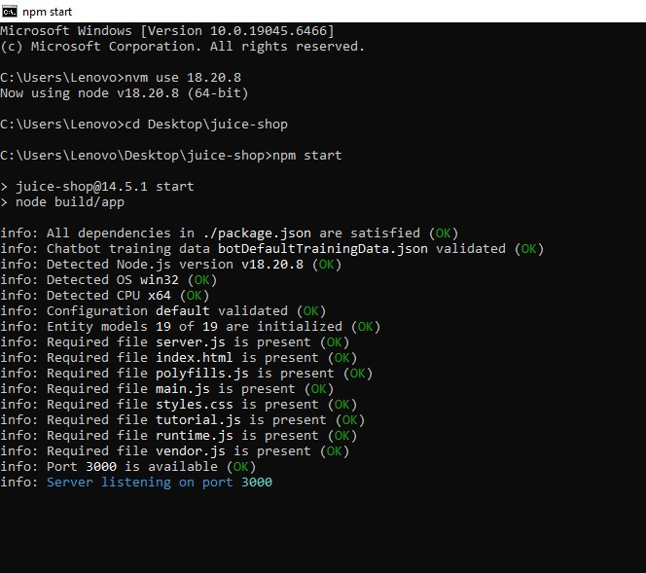
Figure 3: npm start Server listening on port 3000, all dependencies satisfied

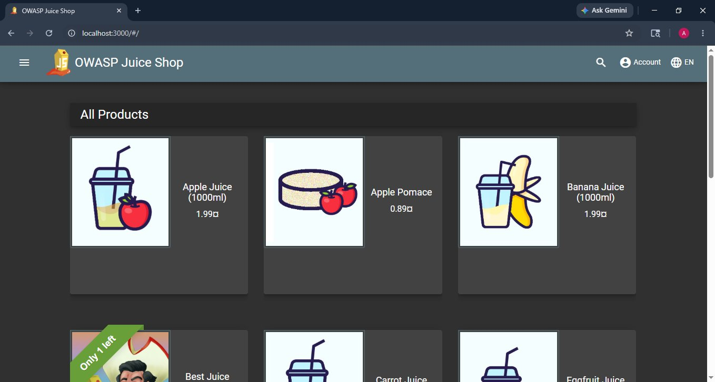
Figure 4: OWASP Juice Shop running at localhost:3000 fully functional after package installation

3. Task 2: Security.js Implementation
A dedicated security module named security.js was created in the OWASP Juice Shop project root. This file centralises all four security implementations.

3.1security.js Part 1 (Lines 1–32)
Figure 5 shows the first half of security.js including package imports, input validation, password hashing, and JWT token generation:
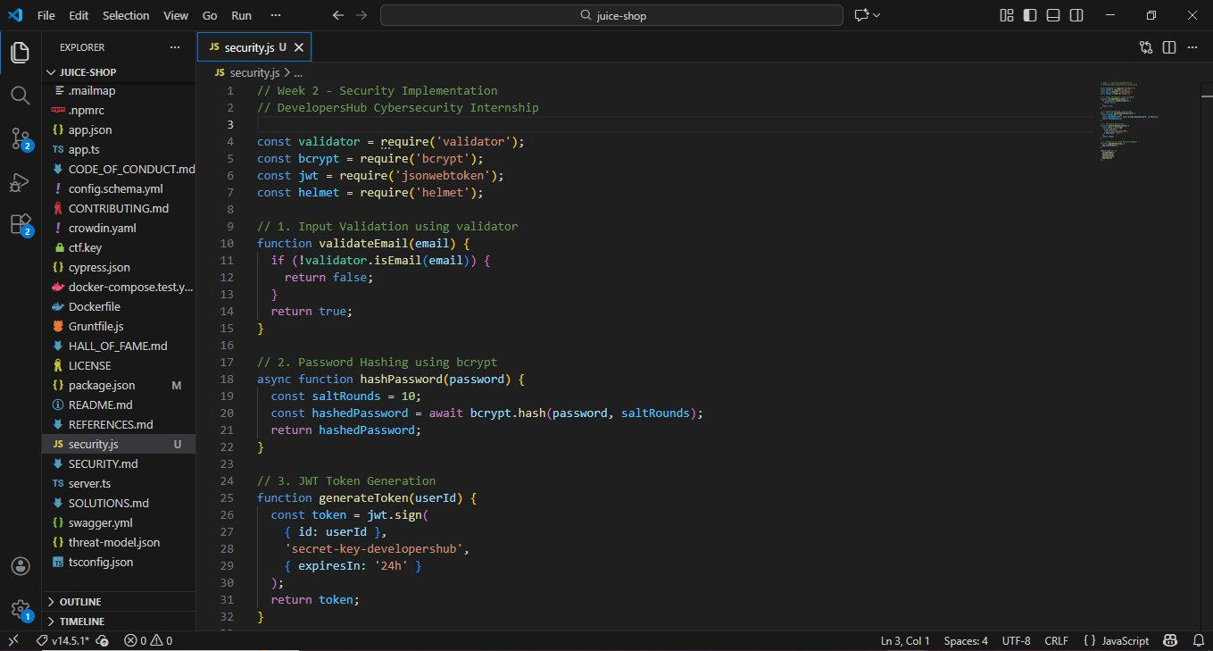
Figure 5: security.js Part 1 validateEmail(), hashPassword(), and generateToken() functions (Lines 1–32)

Implementations in Part 1:
- validateEmail(email): Uses validator.isEmail() to check if the provided email is valid returns true/false
- hashPassword(password): Uses bcrypt.hash() with saltRounds=10 to generate a secure password hash
- generateToken(userId): Uses jwt.sign() with a secret key to generate a JWT token with 24-hour expiry

3.2 security.js Part 2 (Lines 34–45)
Figure 6 shows the second half of security.js covering the Helmet middleware and module exports:
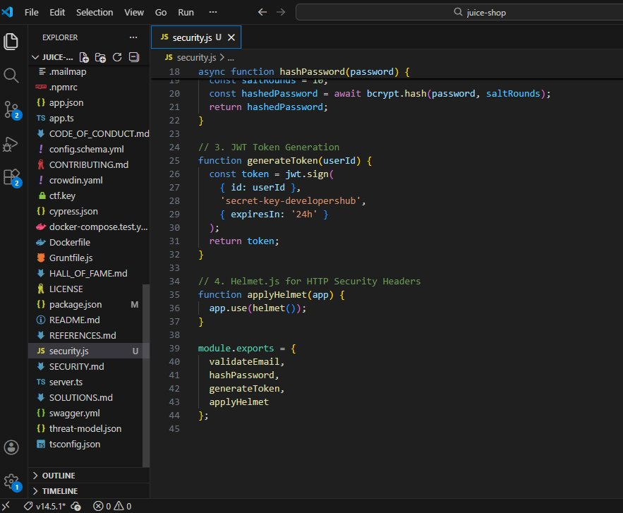
Figure 6: security.js Part 2 applyHelmet() and module.exports (Lines 34–45)

- applyHelmet(app): Applies the helmet() middleware to the Express app, automatically setting security HTTP headers including Content-Security-Policy, X-Frame-Options, and X-Content-Type-Options
- module.exports: All four functions exported for use in other modules

4. Task 3: Security Testing

4.1 Module Syntax Verification
The security.js file was first run directly with Node.js to verify no syntax or import errors:
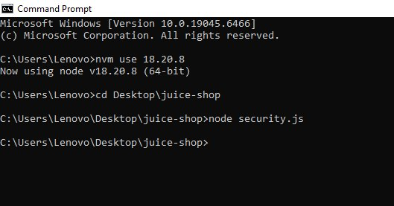
Figure 7: node security.js Module executed with clean exit (no errors)

4.2 Full Functional Test Week2-test.js
A dedicated test script (Week2-test.js) was run to validate all security functions with real inputs:
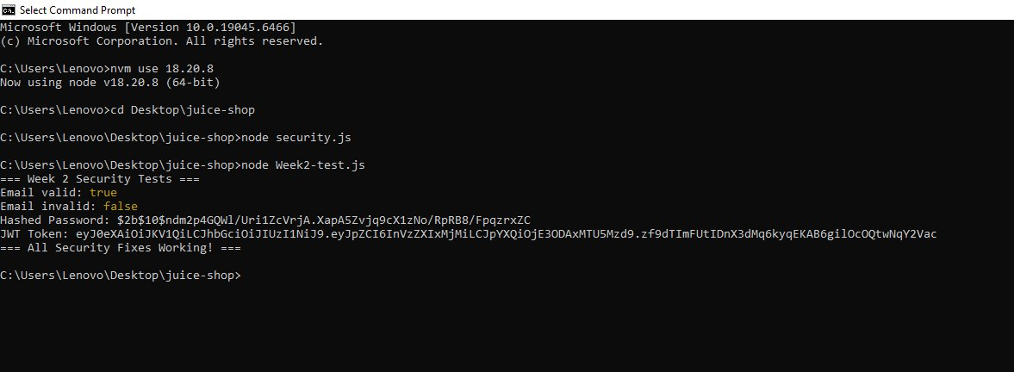
Figure 8: node Week2-test.js All security functions tested: email validation, bcrypt hashing, JWT token generation ALL PASSING
Test results summary:
- Email valid: true valid email address correctly accepted
- Email invalid: false invalid email address correctly rejected
- Hashed Password: 2b10... bcrypt hash with salt rounds 10 generated successfully
- JWT Token: eyJ0eX...full JWT token generated with header.payload.signature format
"=== All Security Fixes Working! ===" confirmed at end of test output.

5. Security Implementation Summary
The table below summarises all security fixes implemented in Week 2 against the vulnerabilities identified in Week 1:

Security Fix | Package | Vulnerability Addressed | Status
Input Validation | validator | SQL Injection, XSS Prevention | FIXED
Password Hashing | bcrypt (salt=10) | Weak Password Protection | FIXED
JWT Authentication | jsonwebtoken | Session Security | FIXED
HTTP Security Headers | helmet | CSP, Clickjacking, XSS Headers | FIXED

6. Observations and Next Steps
- The jsonwebtoken@0.4.1 package shows a deprecation warning for a critical vulnerability. In a production environment, upgrading to v5.0.0+ is strongly recommended.
- The JWT secret key is currently hardcoded. For production use, this should be stored in environment variables using a .env file.
- All four security packages are successfully integrated, establishing the security foundation for Week 3 tasks: Winston logging, Nmap scanning, and final security checklist.

7. Conclusion
Week 2 of the DevelopersHub Corporation Cybersecurity Internship was completed successfully. All four security packages were installed and a centralised security.js module was created implementing email validation, password hashing (bcrypt, salt=10), JWT authentication (24h expiry), and HTTP security headers (Helmet.js). All functions were tested and confirmed working via Week2-test.js.
The application continues to run normally at localhost:3000 after all security implementations.

Week 2 Security Implementation COMPLETE

